Ms. Stills Ms. Baker

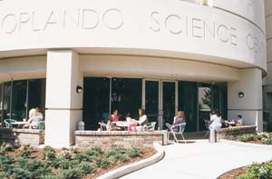
The 1st grade is taking a field trip to the Orlando Science Center on August 22, 2006

Students will need to bring:
- Signed Permission slip turned in by August 19, 2006
- Brown bag lunch
- $15.00 check made payable to Orlando Science Center

I give permission for my child, __________________, to go to the 1st grade field trip to Orlando Science Center.

Print Name & Date Signature

